User Guide

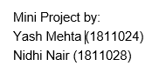



Flashcard App Using Python Tkinter

* Run the python code in python editor(VSCode preferably)
* Click on the "**Geography**" menu in the Menu bar and select the quiz you want to take (i.e. states/states capitals):

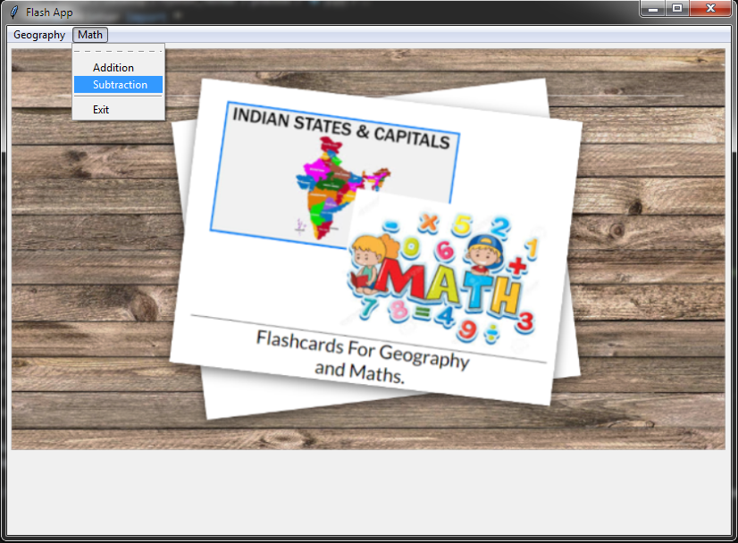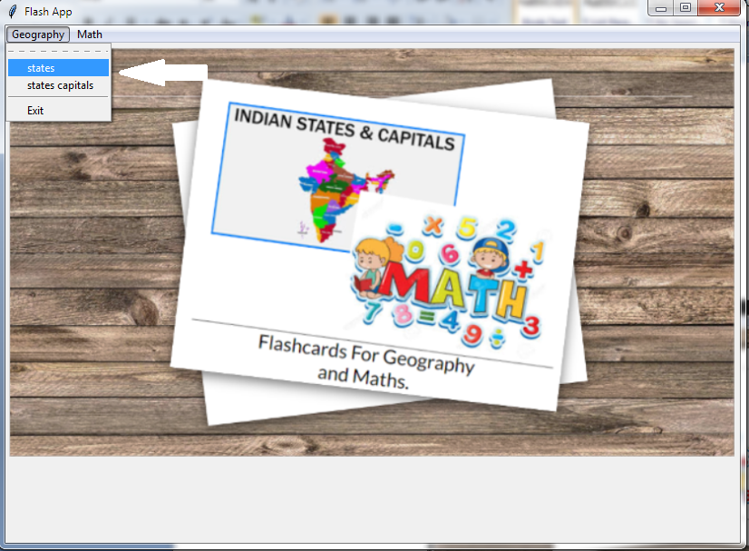

* Type the answer in entry box (eg.Maharashtra) and click on answer button. Depending on the answer given status will be displayed (Correct/Incorrect) along with the correct state name. The question will change as soon as the answer button is clicked.

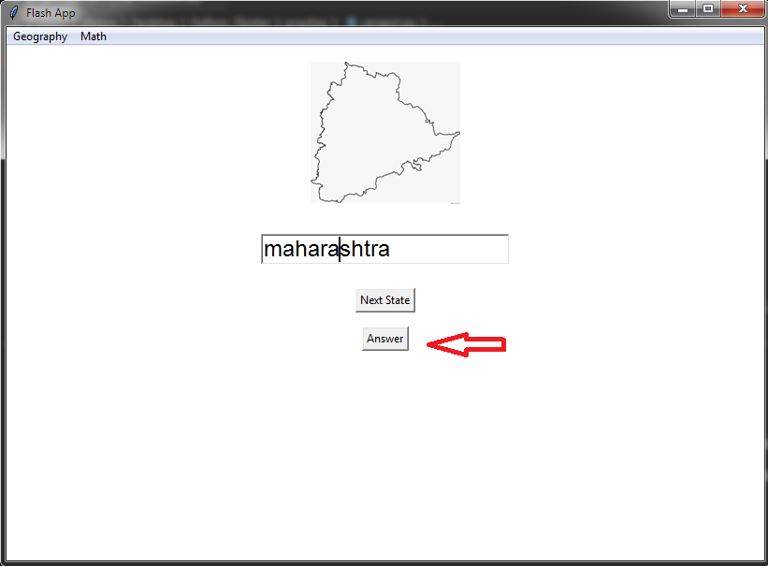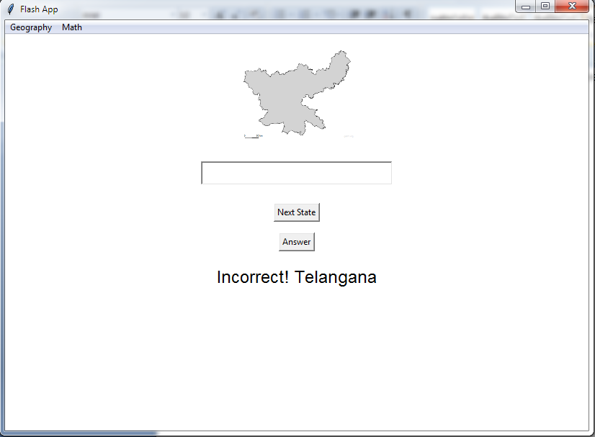

* If you want to go to the next state without answering the current state then click on **“Next State”** button
* If you want to change the quiz goto step 1 and now select “**state capitals**” submenu
* Here the user has to choose 1 correct option out of 3 of the capitals of states and click on “answer” button to verify the result. The status of the answer will be displayed along with correct state and its capital city.

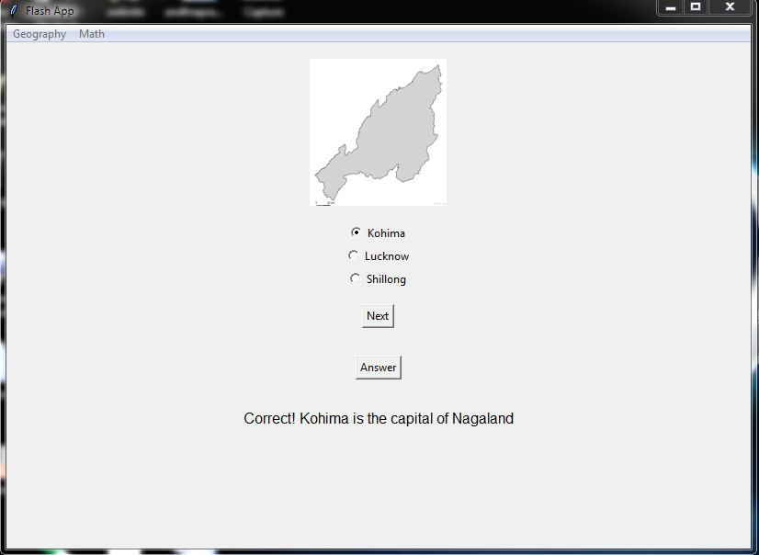

* Click on the “Next” button to change the question.
* If the user want to switch to another quiz then goto step 1 and select “**Math**” menu and click on “**addition**” submenu
* Type the answer in the Entry box provided.

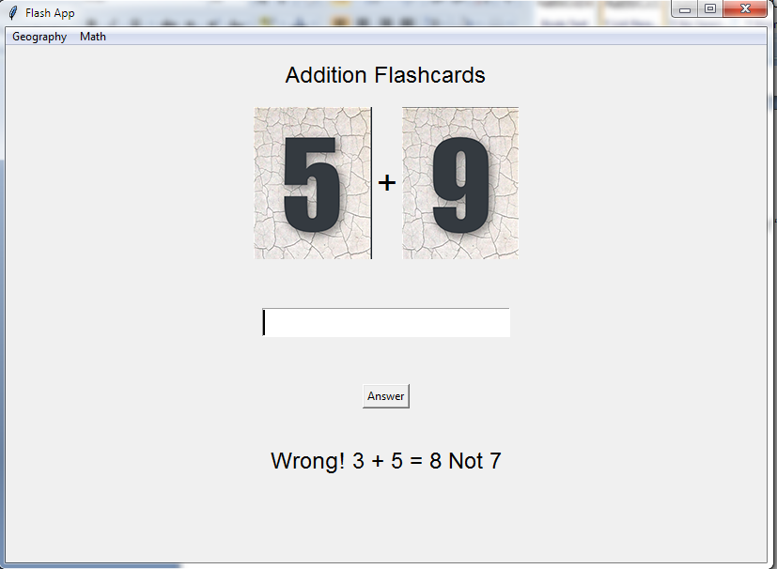

* After logging the answer, the status of the answer will be displayed. The question will change as soon as the answer button is clicked.
* If the user want to give a try at subtraction quiz then goto step 1 and select “**Math**” menu and click on “**subtraction**” submenu
* Type the answer in the Entry box provided.

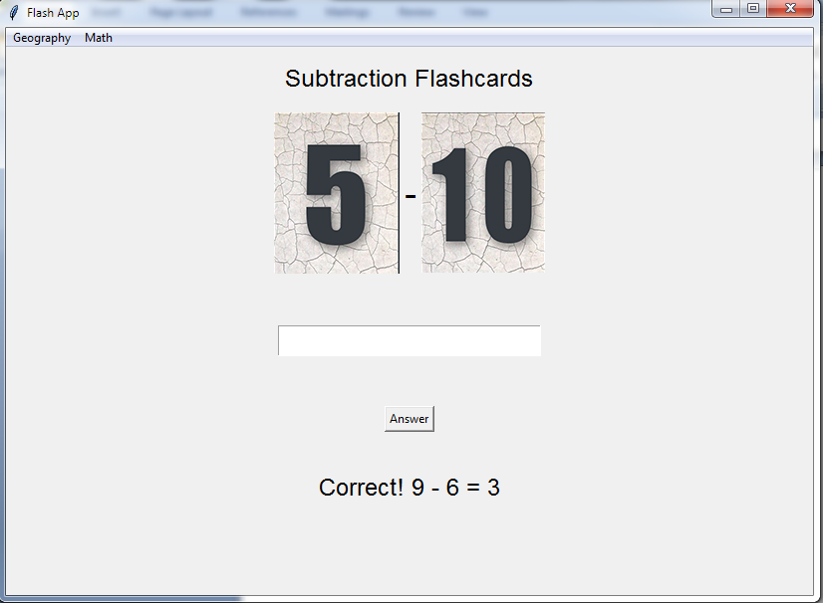

* After logging the answer, the status of the answer will be displayed. The question will change as soon as the answer button is clicked.
* If the user has attempted all the sections or want to leave the app, goto menu bar and click on “**Math/Geography**” menu and click on “**Exit**”

